**University of Wolverhampton**

**School of Mathematics and Computer Science**

**5CS022 Distribute and Cloud Systems Programming**

**Workshop 8 Azure Virtual Machine**

## Overview

In this workshop, you will be introduced to Microsoft Azure cloud service. You will set up an Azure Virtual Machine and set up a Windows Server as a web server.

**Part 1 – Logging into Azure for Education**

It is important that you follow these steps to log into Azure, rather than the "normal" methods, for you to use Azure services as students, with a certain amount of available credits. If you log in via a different route, you may not receive those credits.

With your web browser go to <https://azureforeducation.microsoft.com/> and "Sign in"

Log in with your University email address:  
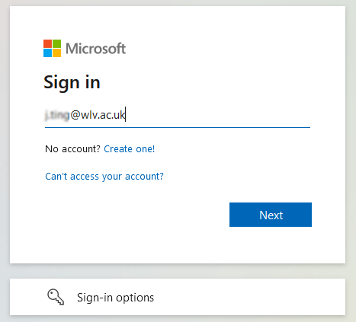

and then make sure that you choose the "Work or school account":  
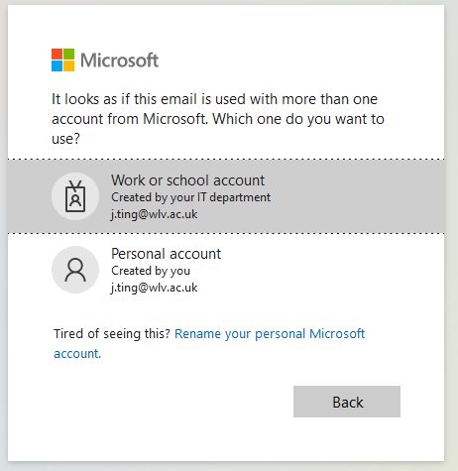

Make sure that you are redirected to the University's login page:

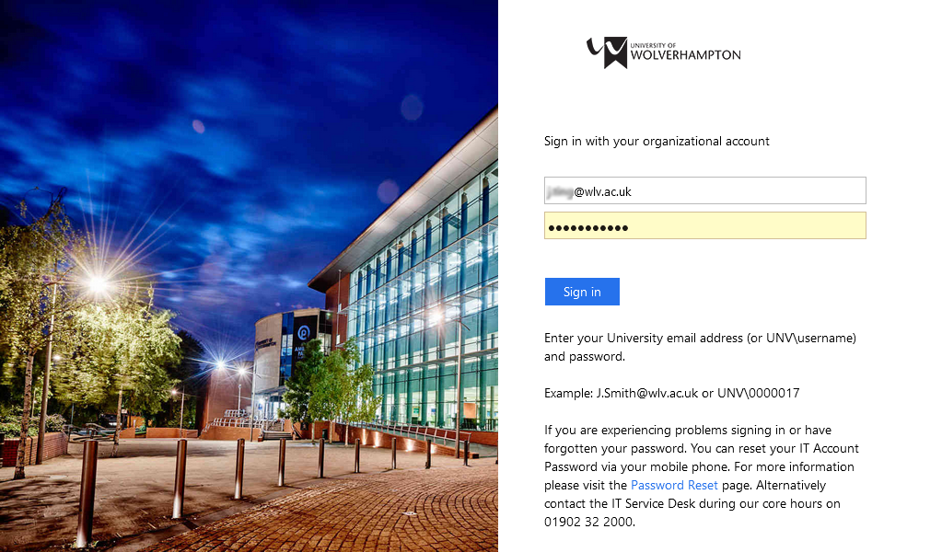

Once you are logged in:

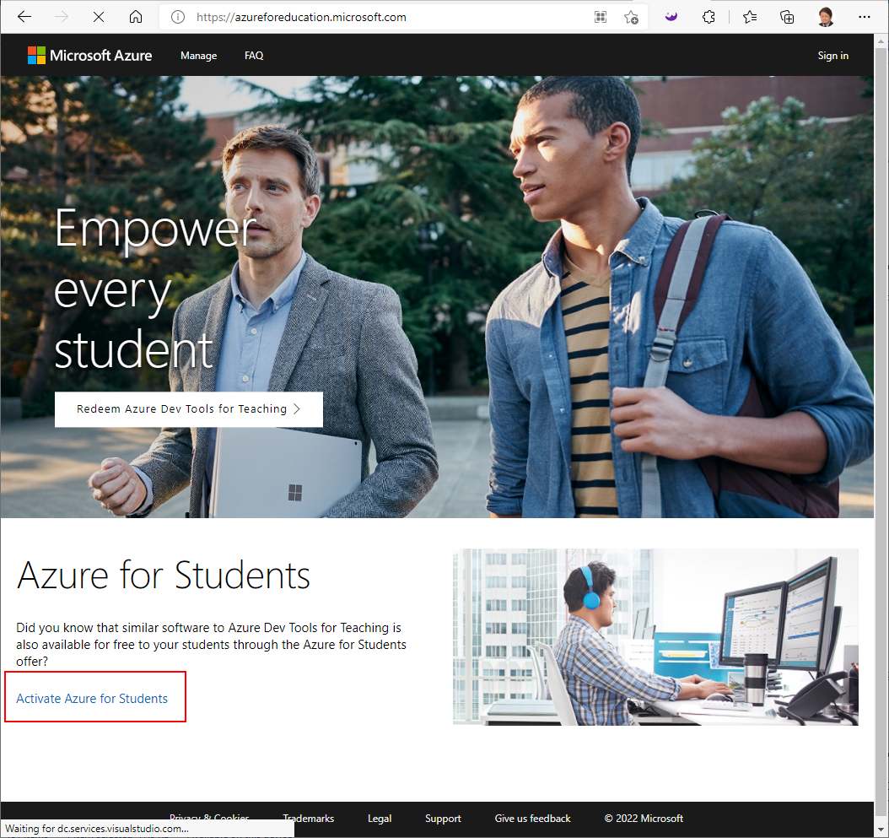

Click on Activate Azure for Students

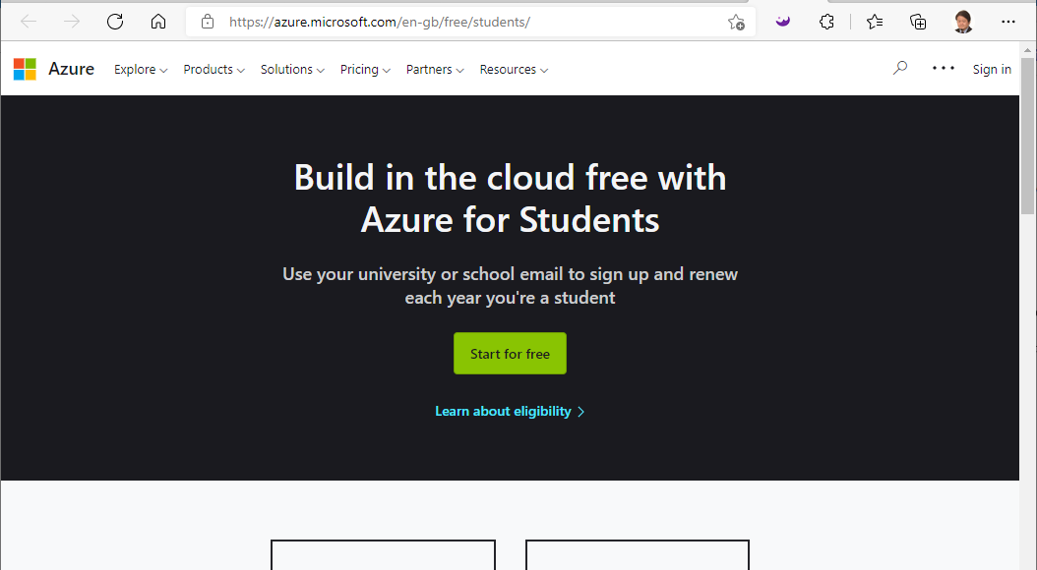

Accept any Cookie prompts.

You should then be redirected to the main Azure portal:

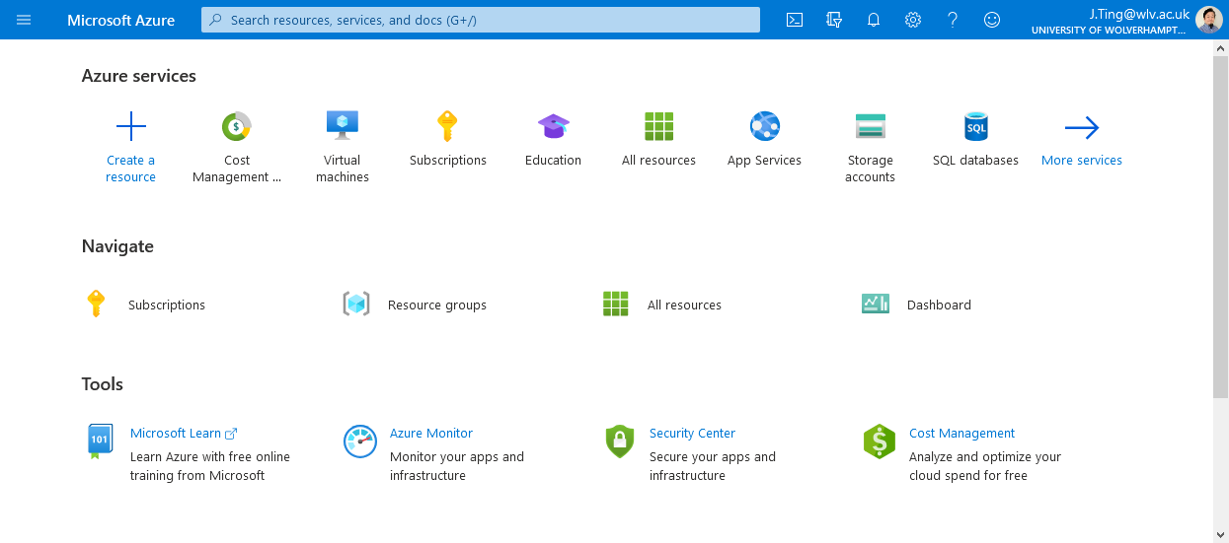

For all future Azure work on this module, always start by logging into <https://azureforeducation.microsoft.com/> to make sure that you are logged in correctly as a student.

**Part 2 – Creating a Virtual Machine on Azure**

* Type virtual machines in the search.  
  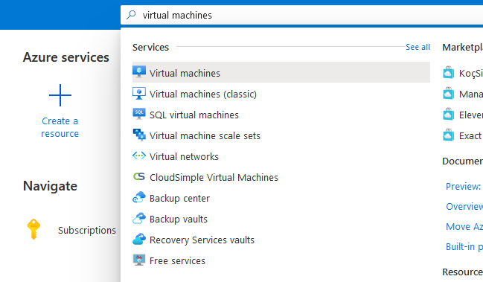
* Under Services, select Virtual machines.
* In the Virtual machines page, select Add.  
  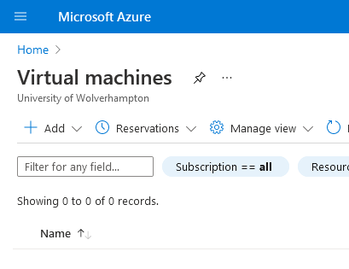
* At the next page fill in the fields similar to below:  
  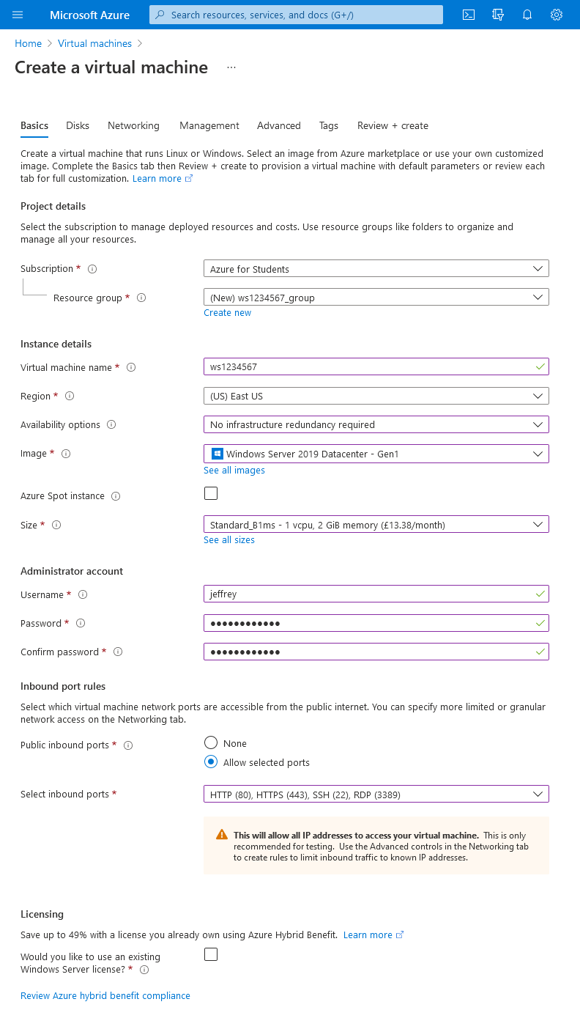
* Make sure the Subscription is on "Azure for Students"
* Name the Virtual Machine name "ws"+ your student ID number, eg. "ws1234567"
* Make sure the Region is on (US) East US
* Set the Availability options to "No infrastructure redundancy required"
* Select the "Windows Server 2019 Datacenter – Gen 1" image
* This part is very important. Make sure select the correct Size: "Standard_B1ms – 1vcpu, 2GiB memory". This is probably the minimum size and cheapest cost that Windows Server 2019 will run in. It is import because if you select a size that is more costly, your available credits will run out very quickly, and when it does, there is nothing that we can do. You don’t get more free credits, until the next academic year.
* Create your administrator user account and password. Please note this information down somewhere. If you forget, you will be locked out of your Virtual Machine and there will be nothing we can do.
* For the Inbound ports rules, select all available ones for now, and those are 80, 443,22 and 3389.

Then click on "Review + create" to validate your Virtual Machine, and it should after a few moments say "Validation passed"

* Then click on "Create" to create the actual Virtual Machine.
* The creation and deployment of the virtual machine will take a few minutes, and whilst it is ongoing, you will see a page similar to this:  
  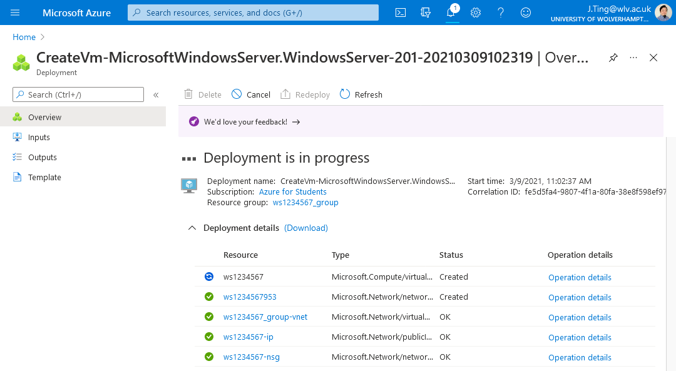
* When it has completed you will see:  
  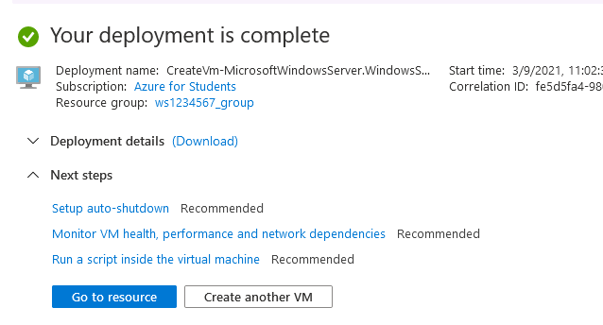
* Click on "Go to resource" to get to:  
  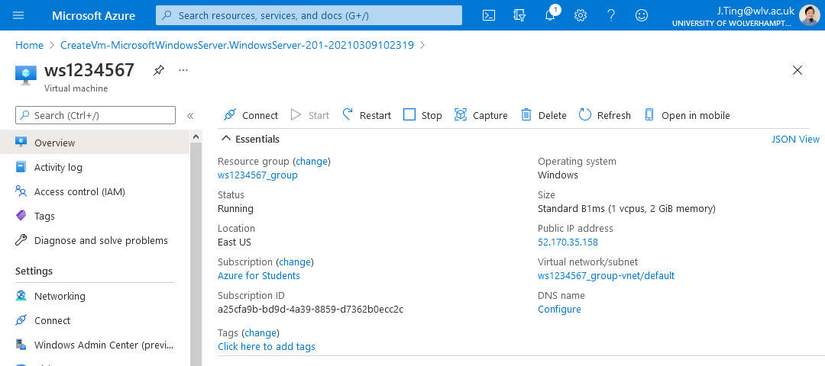
* Please make a note of your server's Public IP address.( eg. 52.170.35.158)

**Part 3 – Connect to virtual machine**

* Select the Connect button on the overview page for your virtual machine.

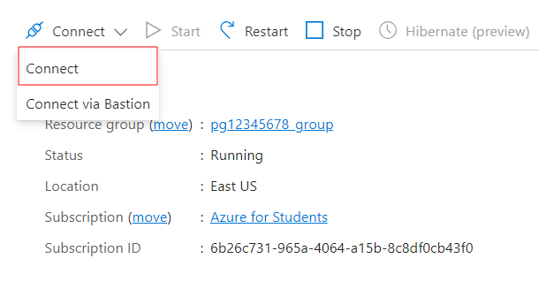

* Select Native RDP, and then click on "Download RDP File":A screenshot of a computer

  Description automatically generated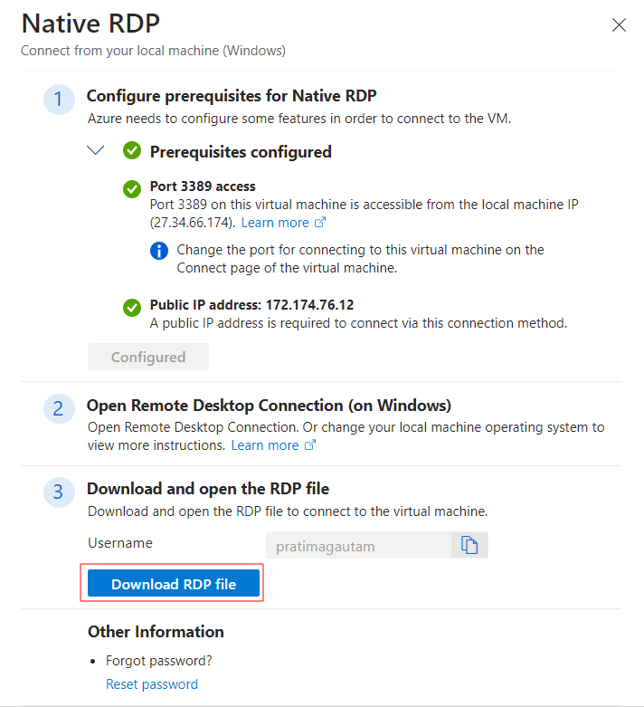
* Make sure you save the RDP file.
* Open the downloaded RDP file and you should get a warning:

* Tick the "Don't ask…" checkbox and click on connect.
* Log in to your Windows Server 2019:  
  A screenshot of a computer

  Description automatically generated
* You may get another warning:

* Tick the "Don't ask…" checkbox and click Yes. It trying to connect to the VM.

You should now be logged into your Windows Server Virtual Machine:

* Click "No" for the network discovery prompt.

**Part 4 – Windows Server as a Web Application Server**

**Task – Setting up IIS**

* Start “Server Manager” if it is not already running.
* Click “Manage”, and then “Add Roles And Features”.
* Click Next.
* Select “Role-Based or feature-based installation” and click next.
* Select your server and click next.
* Click “Web Server”, and drill down into the options. Set them as following:

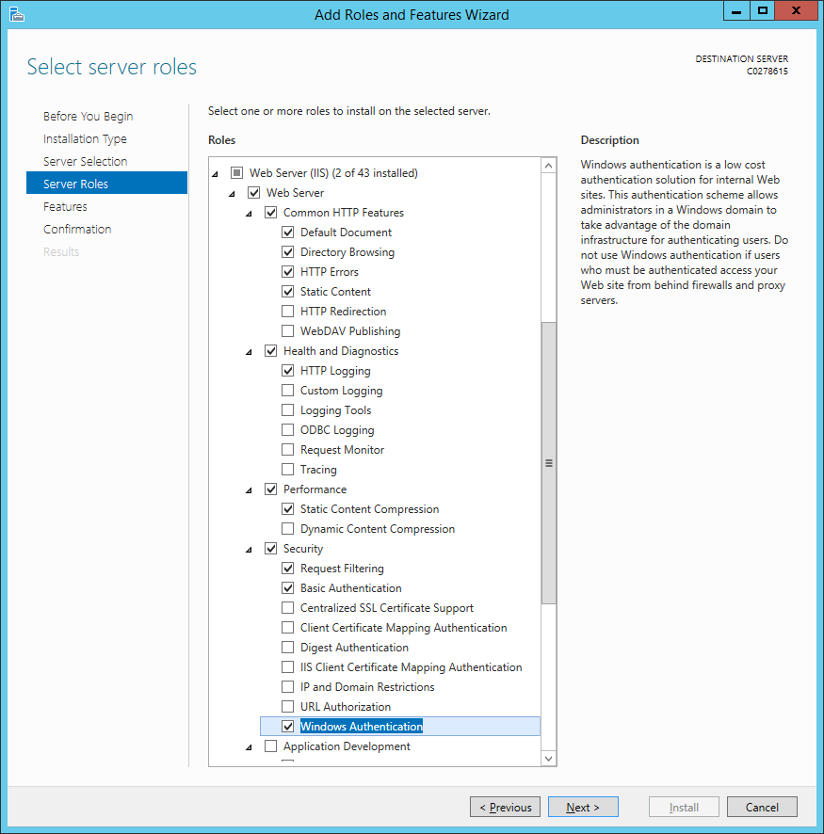

* Also, click “ASP.NET 4.7” under “Application Development”. You will get the following popup:

* Please note, you may get a different ASP.NET version, by the time you do this as it is updated regularly.
* Click “Add Features”.
* Click “Next”.
* And then click “Install”.

* When it has finished installing, click “Close”.
* When you have finished, open Internet Explorer, and go to <http://127.0.0.1>
* You should get a page saying “Internet Information Services”.

**Task – creating a website.**

* Go to the Start Menu, and start IIS.

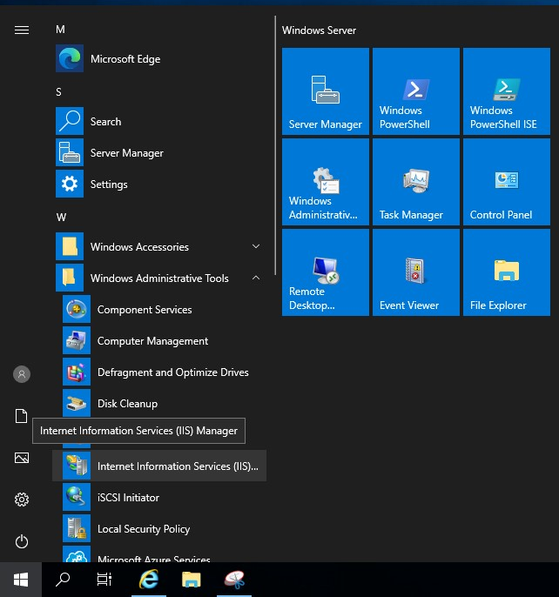

* Click on your server name, from the list on the left of IIS.

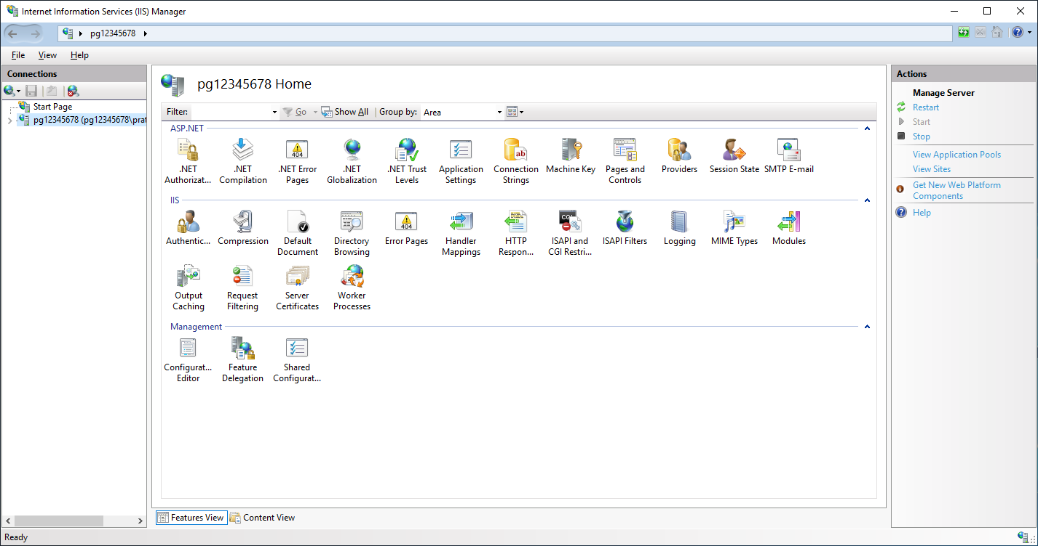

* If you get a message asking, “Do you want to get started with Microsoft Web Platform”, tick “Do not show this message”, and then click “No”.
* You should see “Default Web Site” under “Sites”. Right-click and click “Explore”.

* Windows Explorer should appear.
* Click “View”, “Options”, and then “Change folder and search options”:

* In the “Folder Options” window, click “View”, and scroll down. Untick “Hide extensions for known file types”, and then click “Apply”, and “OK”.

* Create a new text file, called “test.aspx”. Open it for editing.
* Copy and paste the following into the file:

<%@ Page Language="C#" %>

<script language="C#" runat="Server">

void Page_Load(object sender, EventArgs e)

{

lblMessage.Text = "Hello YOUR_STUDENT_NUMBER";

lblServerIP.Text = "Server IP is " + System.Net.Dns.GetHostByName(System.Net.Dns.GetHostName()).AddressList[0].ToString();

lblClientIP.Text = "Client IP is " + HttpContext.Current.Request.UserHostAddress;

lblType.Text = "Authentication: " + User.Identity.AuthenticationType;

lblUser.Text = "Logged on as: " + User.Identity.Name;

lblScheme.Text = "Using protocol: " + Page.Request.Url.Scheme;

}

</script>

<html>

<head>

<title>First ASP.NET page written in Notepad</title>

</head>

<body>

<asp:Label ID="lblMessage" runat="Server" />

<br />

<asp:Label ID="lblServerIP" runat="Server" />

<br />

<asp:Label ID="lblClientIP" runat="Server" />

<br />

<asp:Label ID="lblType" runat="Server" />

<br />

<asp:Label ID="lblUser" runat="Server" />

<br />

<asp:Label ID="lblScheme" runat="Server" />

</body>

</html>

* Save the file
* Using a web browser, go to your website <http://your-ip-address/test.aspx> (e.g. http://52.170.35.158/test.aspx )
* Make sure you use your IP address, not mine.

**Task – website authentication**

* Go back to the Server
* Bring up the IIS window.
* Click on “Default Web Site” again, and from the options on the right, open “Authentication”.
* Click on “Anonymous Authentication”, and click “Disable” on the right.
* Click on “Basic Authentication”, and click “Enable” on the right.

* Click on “Default Web Site”, and the go to “Manage Website”, and click “Restart”, as below:

* Restart your web browser, and go back to   
  <http://your-ip-address/test.aspx>
* You should now be asked for a login.

**Task - Secure (https) website**

* Go to IIS and click on your server name from the list on the left.
* From the options on the right, select “Server Certificates”.
* Under “Actions” on the right, click “Create Self-Signed Certificate”

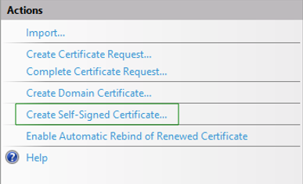

* Where it asks for a friendly name, type in your student number.
* Select “Web Hosting” for “Select a certificate store for the new certificate”.

* Finally, click “OK”.
* Select “Default Web Site” from the “Sites”, and then on the far right, under “Actions”, click “Bindings”.

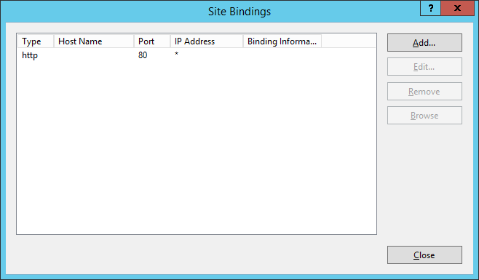

* Click “Add”.
* Under “Type”, select “https”.
* In the “SSL Certificate” box, select the certificate you just created.
* Finally, click “OK”.
* Click “Close”.
* Restart the website again.
* Using your web browser, go to <https://your-ip-address/test.aspx>   
  **(Note it’s HTTPS this time, not HTTP)**
* You may get a message telling you the page is not secure, or telling you there is a problem with this website’s security certificate. Click “Continue”.

This is the end of this workshop.